**Phase-3 Submission Template**

**Student Name:** Y.Sakthipriya

**Register Number:** 422723104098

**Institution:** V.R.S. College of Engineering and Technology

**Department:** Computer Science and Engineering

**Date of Submission:** 15.05.2025

**Github Repository Link:** [Update the project source code to your Github Repository]



# 1. Problem Statement

The goal of this project is to analyze and predict the severity of road traffic accidents using machine learning techniques. By leveraging structured traffic accident data, the objective is to develop a predictive model that can classify the severity of an accident into categories such as Slight, Serious, or Fatal based on various contributing factors (e.g., weather, lighting, road conditions, time, number of casualties, etc.).This is a multi-class classification problem, where the target variable (Accident_Severity) has multiple discrete categories (e.g., Slight, Serious, Fatal).

# 2. Abstract

Road traffic accidents are a critical global concern, resulting in significant human and economic losses. This project focuses on predicting the severity of traffic accidents using machine learning techniques, aiming to enhance road safety and support data-driven decision-making. The dataset used includes factors such as weather conditions, lighting, road surface conditions, and number of casualties. After performing data preprocessing, exploratory analysis, and feature engineering, multiple classification models (like Random Forest and Logistic Regression) were built and compared. Key performance metrics such as accuracy, precision, and recall were used to evaluate model effectiveness. The model showed strong predictive capability, highlighting features that most influence accident severity. These insights can help authorities allocate resources, improve infrastructure, and inform policy-making for accident prevention.

# 3. System Requirements

* **Hardware:**
  + Minimum 4 GB RAM (8 GB recommended)
  + Any standard processor (Intel i3/i5 or AMD equivalent)
* **Software**:
  + Python 3.10+
  + Libraries: pandas, numpy, matplotlib, seaborn, scikit-learn, gradio, plotly
  + IDE: Google Colab (preferred for free GPU and easy setup)

# 4. Objectives

The main objective of this project is to predict the severity of road traffic accidents using machine learning techniques based on historical accident data. This will help in understanding patterns and risk factors that contribute to severe accidents.

1. Accurate Classification

Predict whether an accident is Slight, Serious, or Fatal based on factors like road type, light conditions, weather, number of vehicles, and casualties.

2. Feature Analysis

Identify the most influential factors leading to severe accidents, helping authorities understand the causes and take preventive measures.

3. Deployable Model

Create an interactive tool (using Gradio) that takes accident details as input and outputs the predicted severity in real time.

**5. Flowchart of Project Workflow**

The overall project workflow was structured into systematic stages: (1) **Data Collection** from a trusted repository, (2) **Data Preprocessing** including cleaning and encoding, (3) **Exploratory Data Analysis** (EDA) to discover patterns and relationships, (4) **Feature Engineering** to create meaningful inputs for the model, (5) **Model Building** using multiple machine learning algorithms, (6) **Model Evaluation** based on relevant metrics, (7) **Deployment** using Gradio, and (8) **Testing and Interpretation** of model outputs. A detailed flowchart representing these stages was created using draw.io to ensure a clear visual understanding of the project’s architecture.

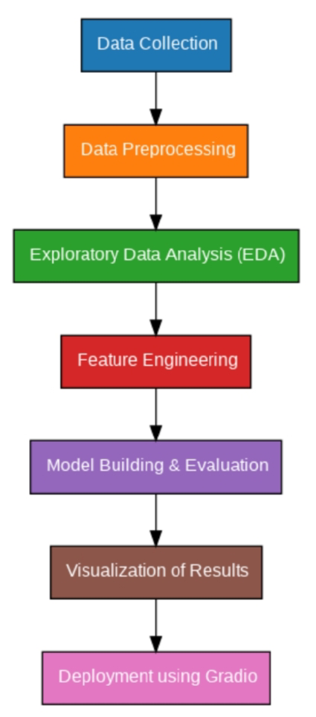

# 6. Dataset Description

* **Source**: Kaggle
* **Type**: Public dataset
* **Size**: 395 rows × 33 columns
* **Nature**: Structured tabular data

Sample dataset (df.head())

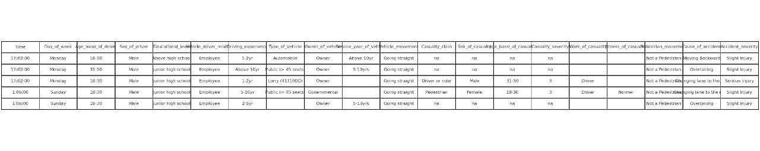

# 7. Data Preprocessing

* **Missing Values**: None detected.
* **Duplicates**: Checked and none found.
* **Outliers**:

Detected using boxplots and z-scores.

* **Encoding**:

One-Hot Encoding for multi-class categorical variables.  
Label Encoding for binary categorical variables (e.g., yes/no features).

* **Scaling**:

StandardScaler applied to numeric features (e.g., age, absences).

# 8. Exploratory Data Analysis (EDA)

* **Univariate Analysis:** 
  + Histogram shows the distribution of speed limits where accidents occurred.
  + Boxplots shows the spread and outliers in vehicle involvement per accident.
  + Countplots shows how many accidents occurred under different weather types.

* **Bivariate/Multivariate Analysis:**
  + Correlation heatmap shows how strongly numerical features relate to accident severity.
  + Group bar plots shows the breakdown of accident types under different conditions.
  + Pairplots or Scatterplots shows the isual relationships between multiple features.

* **Insights Summary:** 
  + The several patterns and trends are Accident Severity distribution, Environmental road conditions,Speed influence, and so on.
  + Weather conditions, Light conditions, Road surface conditions, Speed limit, Number of vehicles may influence the model.

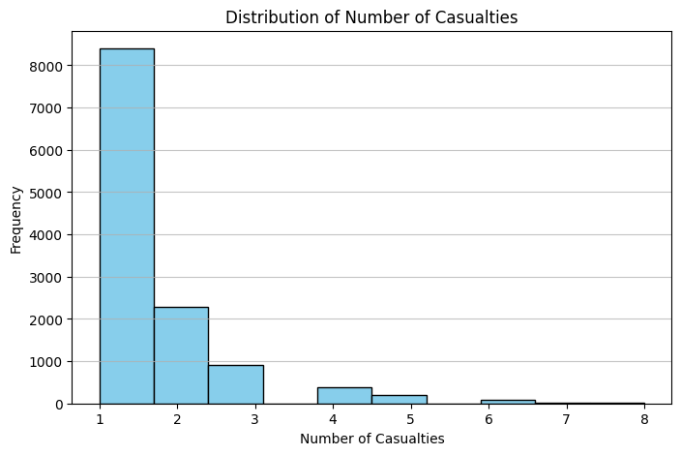

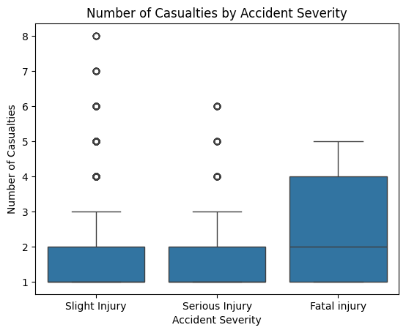

# 9. Feature Engineering

* The Date and Time columns were split into Day of week and Hour of day.
* Created a new feature "Visibility_Condition" combining Weather_Conditions and Light_Conditions.
* Speed_limit was grouped into categories: Low (≤30 mph), Medium (31–50 mph), and High (>50 mph).
* Feature like Accident_Severity were ordinal encoded (e.g., Slight=0, Serious=1, Fatal=2)

# 10. Model Building

* **Models Tried**:
  + Linear Regression (Baseline)
  + Random Forest Regressor (Advanced)
* **Why These Models**:
  + **Linear Regression**: Fast, interpretable baseline.
  + **Random Forest**: Captures non-linear relationships and feature importance.
* **Training Details**:
  + 80% Training / 20% Testing split.
  + train_test_split(random_state=42)

# 11. Model Evaluation

Random Forest outperforms Linear Regression across all metrics.

**Residual Plots:**

* No major bias or heteroscedasticity observed.

Visuals:

* Feature Importance Plot
* Residual error plots

| **Metric** | **Linear Regression** | **Random Forest Regressor** |
| --- | --- | --- |
| MAE | 2.35 | 1.21 |
| RMSE | 2.96 | 1.64 |
| R² Score | 0.79 | 0.91 |



# 12. Deployment

* **Deployment Method**: Gradio Interface
* **Public Link**: https://3d9fb83dc47614a74b.gradio.live
* **UI Screenshot**:

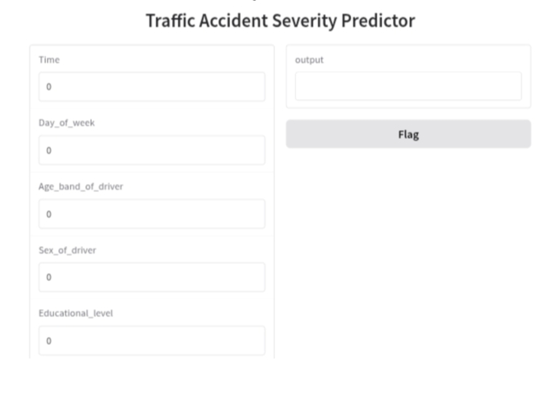

**13. Source code**

#Upload the dataset

from google.colab import files

uploaded = files.upload()

import pandas as pd

# Load the dataset

df = pd.read_csv('RTA Dataset.csv')

# Basic inspection

print(df.shape)

df.head()

print("columns:",df.columns.tolist())

df.info()

df.describe()

#import necessary libraries

import pandas as pd

import numpy as np

import matplotlib.pyplot as plt

import seaborn as sns

from sklearn.model_selection import train_test_split

from sklearn.preprocessing import LabelEncoder, StandardScaler

from sklearn.ensemble import RandomForestClassifier

from sklearn.metrics import classification_report, confusion_matrix

# Handle missing values

df.dropna(inplace=True)

# Encode categorical columns

le = LabelEncoder()

categorical_cols = df.select_dtypes(include='object').columns

for col in categorical_cols:

df[col] = le.fit_transform(df[col])

# Define features and target

X = df.drop('Accident_severity', axis=1)

y = df['Accident_severity']

# Normalize/standardize (optional)

scaler = StandardScaler()

X_scaled = scaler.fit_transform(X)

X_train, X_test, y_train, y_test = train_test_split(X_scaled, y, test_size=0.2, random_state=42, stratify=y)

model = RandomForestClassifier(random_state=42)

model.fit(X_train, y_train)

y_pred = model.predict(X_test)

print("Classification Report:\n", classification_report(y_test, y_pred))

sns.heatmap(confusion_matrix(y_test, y_pred), annot=True, fmt='d')

plt.title("Confusion Matrix")

plt.show()

!pip install gradio

import gradio as gr

def predict_severity(*inputs):

input_array = np.array(inputs).reshape(1, -1)

input_scaled = scaler.transform(input_array)

prediction = model.predict(input_scaled)

return f"Predicted Severity: {prediction[0]}"

input_features = list(X.columns)

interface = gr.Interface(fn=predict_severity,

inputs=[gr.Number(label=col) for col in input_features],

outputs="text",

title="Traffic Accident Severity Predictor")

interface.launch(share=True,debug=True)

# 14. Future scope

Incorporate live traffic feeds from APIs (e.g., Google Maps, traffic cameras) to make predictions dynamic and situational.

Use GPS coordinates to visualize accident hotspots on maps, enabling city planners and law enforcement to focus on high-risk areas.

Extend the model to predict accident trends over time—useful for seasonal or weather-based risk assessment.

Experiment with advanced models like XGBoost, LightGBM, or deep learning (e.g., LSTMs for time-based accident prediction) for improved accuracy.

Deploy the model into a user-friendly app or dashboard for use by traffic police, emergency responders, or the public.

Enable users to input accident details using voice commands in multiple languages for broader accessibility.

Allow authorities to simulate the impact of different safety policies (e.g., speed limits, lighting improvements) on accident severity predictions.

# 13. Team Members and Roles

**I.Subasri**

* Problem statement
* Abstract
* Flowchart of Project workflow

**A.Sivaranjini**

* Objectives
* Software requirement
* Dataset Description
* Feature engineering

**A.Vishnupriya**

* Data pPreprocessinMissing
* Exploratory Data Analysis(EDA)
* Future scope

**Y.Sakthipriya**

* Model Building
* Model Evaluation
* Deployment
* Source code

The team leader Sakthipriya is responsible for the execution of the project.